**We used maven project in our project.**

Maven is a build management tool and maven project contains POM.xml

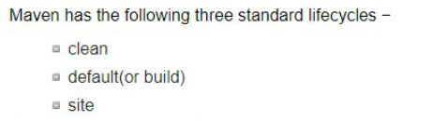

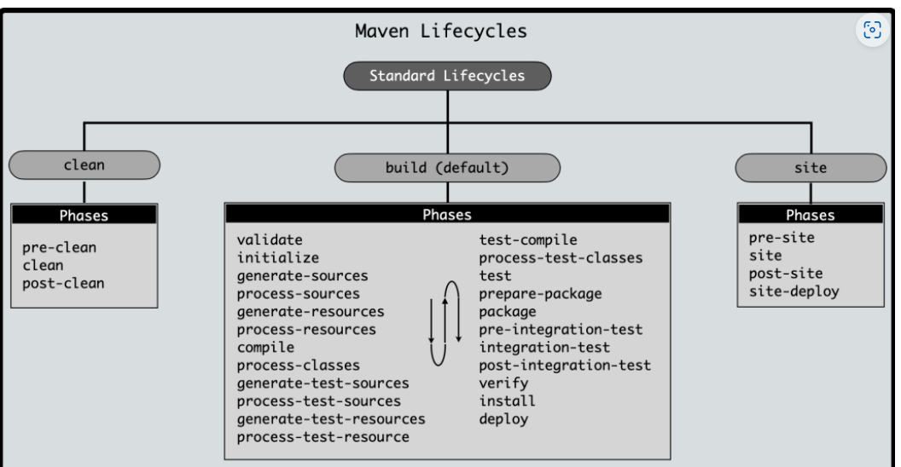

**The Build default Maven consists of 8 major phases:**

1. Validate,
2. Compile,
3. Test,
4. Package,
5. Integration Test,
6. Verify,
7. Install,
8. and Deploy.

Each phase represents a specific step in the build process and has its own set of goals to be executed.

